

**PROCESS AND SUPPLY NETWORK DESIGN OF THE COMPANY TOYOTA**

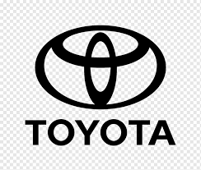

**OPERATIONS ANALYTICS (7036SSL)**

**SUBMITTED BY**

**CLINTS THEEYATTUPARAMBIL JOHN**

**STUDENT ID – 13518992**

**MODULE LEADER - PINGFAN WANG**

**Content**

1. **Overview** 
   1. **Introduction to the organization…………………………………………..4**
   2. **Scope of Organization Area…………………………………………………..4**
   3. **Impact of Operational Area on Organizational performance…5**
2. **The Planning Environment and Key Variables…………………………………6**

**2.1 Key Decisions required in Planning Environment………………………6**

**2.2 Key Variables required in Planning Environment………………………6**

**3. Organization’s Analytic Capabilities……………………………………………7**

**3.1 Analysis of the Operation’s Process………………………………………7**

**3.2 The Key Analytical Tools and Resources………………………………..7**

**3.3 Illustrations to the Analytical Tool Identified ………..………………8**

**4. Investigation of Organization’s Operations using the 4 V’s and Product process matrix model……………………………………………………………………………….10**

**4.1 Application of the Tools to the Operations Functions ……………10**

**4.2 Explanation of its application to the operations functions…….11**

**4.3 Use of appropriate examples in discussing its applications…..12**

**5. Key Challenges and Recommendation……………………………………………13**

**6. Conclusion…………………………………………………………………………………….14**

**References………………………………………………………………………………………14**

**Table of Figures**

**Figure 1 – leading motor vehicles company in 2020 and 2021, based on sales worldwide…………………………………………………………………..4**

**Figure 2 – Just in time inventory cycle……………………………………..5**

**Figure 3 – Illustration of Toyota production system………………….6**

**Figure 4 – Toyota’s production system……………………………………..8**

**Figure 5 – Illustration of VRIO analysis…………………………………….9**

**Figure 6 - Illustration of Kanban……………………………………………….9**

**Figure 7 – Product process matrix with volume and variety………10**

**Figure 8 – Illustration of 4 v’s model…………………………………………11**

**Figure 9 – Toyota’s product process matrix……………………………….11**

**Figure 10 – Explanation of different variables in product process matrix……………………………………………………………………………………….12**

**1. Overview of Toyota**

**1.1 Introduction to the Organization**

Toyota Motor Corporation, a prominent Japanese multinational automaker, is well known for its dedication to quality, innovation, and operational excellence. Kiichiro Toyoda founded the company in 1937, and since then it has expanded to become one of the world's largest automakers, continually producing outstanding cars and cutting-edge technology. Toyota has become a global leader in process design and supply network management due to its emphasis on operational efficiency.

Figure Leading motor vehicle manufacturers worldwide in 2020 and 2021, based on sales worldwide (inn million units)

**1.2 Scope of Organization Area**

Toyota Motor Corporation's scope of organisation in process design is rooted in the Toyota Production System (TPS). The TPS is a renowned production system focused on achieving the complete elimination of waste and maximising efficiency. With a strong emphasis on jidoka (automation with a human touch) and just-in-time manufacturing, Toyota efficiently produces vehicles of sound quality, meeting customer requirements.

Toyota's supply network design is heavily influenced by the Just-in-Time (JIT) concept, aiming for efficient and lean operations. JIT focuses on delivering materials precisely when needed, reducing waste and excess inventory. Toyota keeps close ties with its suppliers and employs JIT practises to cut costs, shorten lead times, and improve supply chain effectiveness. This strategy streamlines the manufacturing process and enhances overall performance.

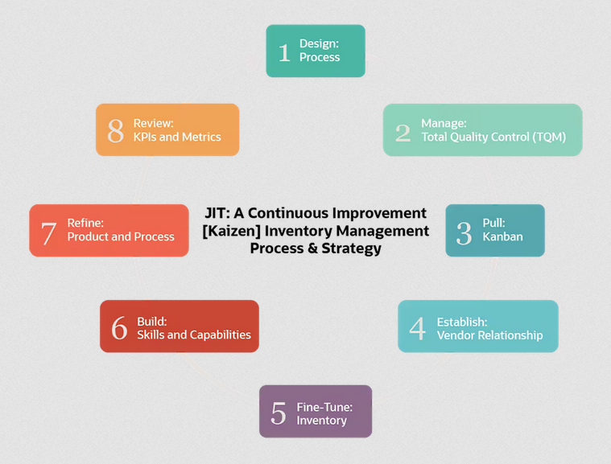

Figure Just-in-time inventory cycle

**1.3 Impact of Operational Area on Organisational Performance**

The performance of Toyota is significantly influenced by the design of its operational processes and supply network. A well-optimised process design, in line with lean principles, allows for efficient production, waste reduction, and enhanced quality.

Moreover, Toyota's supply network design, which incorporates Just-in-Time principles, guarantees the punctual delivery of components, reduces inventory costs, and improves overall efficiency in the supply chain. The successful integration of these design elements within Toyota's operational area plays a vital role in their ability to achieve operational excellence, cost savings, and high levels of customer satisfaction.

Figure Illustration of the Toyota Production System (TPS)

**2. Planning Environment and Key Variables**

**2.1 Key Decisions Required in Planning Environment of Toyota**

Toyota needs to decide on several crucial issues in order to maintain effective operations and performance. The selection of products and processes, layout design, capacity planning, technology integration, and distribution network design are a few of the crucial considerations the organisation should have to make in its planning environment. The decisions regarding inventory management, risk management, supplier selection, and cost management should also have to be made for the company's long standing in the competitive market.

**2.2 Key Variables Required in Planning Environment of Toyota**

1. **Lean manufacturing principles**: Toyota's planning environment is influenced by waste reduction, continual improvement, and respect for people.
2. **Customer-centric approach**: Planning and decision-making are driven by addressing client needs and assuring satisfaction.
3. **Just-in-Time (JIT) production**: Reducing stock levels and coordinating production with demand by using precise forecasts and effective supply chain management.
4. **Jidoka (Automation with human touch):** To assure product quality and prevent faults, one must balance automation with human intervention and quality control.
5. **Kaizen (Continuous improvement):** Encouraging staff members to find and implement process changes at all levels.

(Yamamoto, K., Milstead, M., & LIoyd, R. (2019)).

**3. Analytical capabilities of the organisation**

**3.1 Analysis of the operational process**

Toyota's operations management approach is centred around continuous improvement, kaizen, and lean manufacturing, aiming for efficiency, high quality, and waste reduction. By empowering workers to identify and solve problems, the company ensures defect-free production. Operations managers play a crucial role in setting goals, devising strategies, and implementing new procedures to enhance performance. The interconnectedness between operations management and functions like human resources management and marketing is evident as Toyota invests in employee training and upholds a reliable brand image. Treating product design and design processes together is vital to ensure efficient operations and resource optimization. Overall, Toyota's operations management strategy has contributed to its status as a leading global car manufacturer, selling millions of vehicles annually.

**3.2 The Key Analytical Tools and Resources**

The VRIO analysis evaluates Toyota's resources and capabilities using criteria of Value, Rarity, Inimitability, and Organization. It identifies key resources like efficient manufacturing, global facilities, partnerships, intelligent driving technology, and rapid innovation. Toyota's core competencies lie in technological expertise, support from the Toyota Group, cost competitiveness, and brand popularity, providing sustained advantages in the automotive industry.

The Toyota Production System (TPS) serves as a key analytical tool and resource for Toyota. TPS is a lean manufacturing system focused on eliminating waste and achieving efficiency. It incorporates concepts like jidoka and Just-in-Time, enabling high-quality production that meets customer requirements. TPS provides competitive advantages for Toyota globally.

Kanban is a workflow management system used by agile software development teams. It utilises a board with cards representing work items, which are moved across columns to indicate status. Kanban enables teams to visualise and continuously deliver valuable features, improving performance and collaboration.

**3.3 Illustration to the Analytical Tool**

Figure Toyota’s Production System

The figure 4 illustrates Toyota's production system, emphasizing important principles such as just-in-time production, built-in quality, and standardized work. These principles are aimed at achieving high-quality products, minimizing costs, and ensuring shorter lead times.

Figure Illustration of VRIO analysis

The figure 5 represents the key factors in assessing a competitive advantage through VRIO analysis. It emphasizes the importance of valuable, rare, and inimitable resources that are well-organized, leading to sustainable competitive advantages.

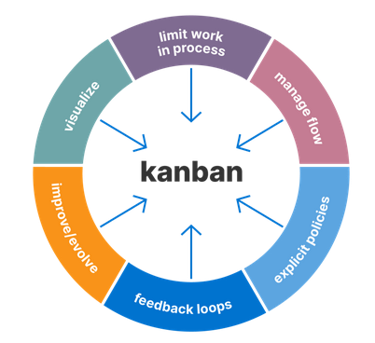

Figure Illustration of Kanban

The figure 6 represents the use of Kanban as a method to visually represent work, adapt and improve processes over time, set limits on work in progress, utilize feedback loops, and manage flow with clear and explicit policies.

**4.** **Investigation of Organization’s Operations using the 4 V’s and Product process matrix model**

**4.1 Application of the Tools to the Operation’s Function**

For the company Toyota, we have considered the product-process matrix and the 4 V's model.

The product-process matrix, also known as the operations matrix or the manufacturing grid, is a tool used to classify products and processes based on their volume and variety characteristics. It helps organisations, including Toyota, make strategic decisions regarding their operations and production systems.

Figure Product process matrix with Volume and Variety

The 4V model is another helpful framework for studying products and processes in addition to the product-process matrix. The 4V model is centred on a product's four most important dimensions: Visibility, Volume, Variety, and Variation

Figure Illustration of 4 V’s model

**4.2 Explanation of its Application to the Operation’s Function**

The following is how the product-process matrix can be used to analyse Toyota's operations:

Figure Toyota’s Product Process matrix

Toyota's product process matrix comprises four categories:

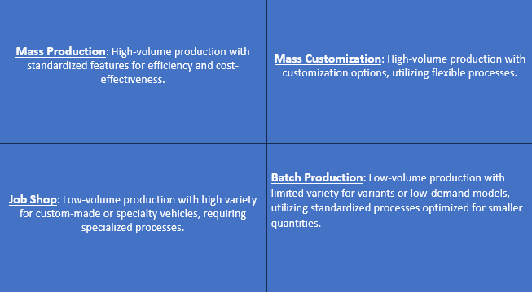

Figure Explanation of different variables in Product-process Matrix

Following is the application of 4 V’s in the company Toyota:

**Volume**

Toyota achieves high-volume production for popular models like Corolla and Camry, optimizing costs and meeting customer demand efficiently.

**Variety**

Toyota balances standardization and mass production with a wide array of models, trims, and customization options, utilizing flexible processes and component modularization to offer variety without sacrificing efficiency.

**Variations**

Toyota minimizes variation through lean manufacturing, just-in-time production, modularization, and flexible assembly lines, balancing efficiency, and customer preferences.

**Visibility**

Toyota enhances visibility by implementing lean management and visual control systems, enabling customers to track orders and gain manufacturing insights, fostering trust and satisfaction.

**4.3 Use of Appropriate Examples in Discussing its application**

Toyota uses the product-process matrix in its operations. Customization is done through flexible manufacturing systems and computer-aided design (Job Shop). Batches are optimized using kanban systems and just-in-time manufacturing (Batch). Mass production is streamlined through lean manufacturing and the Toyota Production System (Assembly Line). Continuous flow production relies on automation, robotics, and data analytics (Continuous Flow). This approach enables Toyota to offer customized vehicles, enhance efficiency, and uphold high-quality standards across their production processes.

**5. Key Challenges and Recommendations**

**Challenges**

**Global supply chain complexity:** Managing a global supply chain with suppliers, production facilities, and distribution networks across countries presents challenges in coordinating activities, transportation, customs, and cultural differences.

**Demand variability:** Toyota's challenge lies in managing demand variability for diverse vehicle models, requiring effective forecasting, inventory management, and production adjustment to minimize lead times and balance inventory levels.

**Balancing efficiency and innovation:** Toyota's emphasis on efficiency and standardization through TPS can hinder innovation and flexibility to meet evolving market needs.

**Adapting to regulatory and environmental requirements:** Ensuring compliance with diverse regulatory standards and environmental regulations in various markets poses challenges for Toyota's process and supply network design. Adapting and integrating sustainability practices are crucial for optimal performance.

**Recommendations**

To achieve optimal performance in process and supply network design, Toyota should focus on several key areas. Firstly, they should improve visibility throughout their supply chain by utilizing advanced technology and systems. Collaborating closely with suppliers is also important to reduce lead times and respond effectively to demand variability. Embracing agile manufacturing practices that combine efficiency and innovation will help strike a balance. Robust forecasting and demand planning capabilities, along with compliance to regulations and sustainability practices, should be prioritized. Investing in talent development and fostering a culture of innovation and collaboration will drive continuous improvement. Leveraging digital technologies and implementing risk management strategies will further enhance efficiency. Regular evaluation and optimization of the supply network will reduce costs and ensure Toyota remains competitive in the automotive industry.

**Conclusion**

Toyota Motor Corporation has firmly established itself as a top automaker worldwide by consistently prioritizing excellence, innovation, and continuous improvement. By organizing its products using the product process matrix, Toyota ensures efficient and cost-effective mass production while satisfying customer preferences and specific requirements. To sustain its position, Toyota must focus on sustainability, invest in research and development, promote innovation, and manage risks effectively to meet the changing expectations of stakeholders and customers.

**References**

Morgan, J., & Liker, J. K. (2020). *The Toyota Product Development System*. <https://doi.org/10.4324/9781482293746>

Corporation., T. M. (n.d.). *Toyota production system: Vision & Philosophy: Company*. Toyota Motor Corporation Official Global Website. <https://global.toyota/en/company/vision-and-philosophy/production-system/>

*Case study of toyota: Significance of Operation Management in manufacturing sector*. Ivory Research. (n.d.). <https://www.ivoryresearch.com/samples/case-study-of-toyota-significance-of-operation-management-in-manufacturing-sector/>

NetSuite.com. (n.d.). *Just-in-time inventory: All you need to know*. Oracle NetSuite. <https://www.netsuite.com/portal/resource/articles/inventory-management/just-in-time-inventory.shtml>

Carlier, M. (2023, April 27). *Motor vehicle manufacturers: Largest companies by sales 2022*. Statista. <https://www.statista.com/statistics/275520/ranking-of-car-manufacturers-based-on-global-sales/>

*Toyota*. Toyota Production System. (n.d.). <https://www.toyotauk.com/toyota-in-the-uk/how-we-manufacture/toyota-production-system>

Yamamoto, K., Milstead, M., & LIoyd, R. (2019). A Review of the Development of Lean Manufacturing and Related Lean Practices: The Case of Toyota Production System and Managerial Thinking. *International Management Review*. Retrieved from <https://www.researchgate.net/profile/Robert-Lloyd->13/publication/340449306_A_review_of_the_development_of_lean_manufacturing_and_related_lean_practices_The_case_of_Toyota_production_system_and_managerial_thinking/links/5f970170a6fdccfd7b7fe1c8/A-review-of

*An analysis of Toyota’s Operations Management: Business Essay Example*. EssayBizLab. (n.d.). <https://essaybizlab.com/an-analysis-of-toyotas-operations-management/>

Smith, O. (2019, January 23). *Toyota VRIO analysis - competitive advantages, core competencies*. Rancord Society. <https://www.rancord.org/vrio-analysis-toyota-motor-corporation-core-competencies-competitive-advantages>

Corporation., T. M. (n.d.). *Toyota production system: Vision & Philosophy: Company*. Toyota Motor Corporation Official Global Website. <https://global.toyota/en/company/vision-and-philosophy/production-system/>

Allred, J. (2021, September 6). *Home*. 5S Today. <https://blog.5stoday.com/the-toyota-production-system-house/>

Aha! (2023, January 17). *What is Kanban? origin, definitions, and tips for implementation*. What Is Kanban? Origin, Definitions, and Tips for Implementation | Aha! software. <https://www.aha.io/roadmapping/guide/agile/what-is-kanban>

*The contradictions that drive Toyota’s success*. Harvard Business Review. (2014, August 1). <https://hbr.org/2008/06/the-contradictions-that-drive-toyotas-success>

Integrated report 2022 - トヨタ自動車株式会社 公式企業 ... (n.d.). <https://global.toyota/pages/global_toyota/ir/library/annual/2022_001_integrated_en.pdf>

*Process matrix powerpoint PPT template bundles*. SlideTeam. (n.d.). <https://www.slideteam.net/process-matrix-powerpoint-ppt-template-bundles.html>

Hattangadi, D. V. (2022, September 26). *What are the 4 VS of operations management*. Dr. Vidya Hattangadi. <https://drvidyahattangadi.com/what-are-the-4-vs-of-operations-management/>